CYPHER
Sample Website QA Report
DEMONSTRATION ASSESSMENT — NOT COMMISSIONED CLIENT WORK
Target: OWASP Juice Shop public demonstration application
Assessment date: 23 August 2026
Primary environment: Opera on Windows · Ultrawide desktop
Responsive checks: narrow/mobile-like viewport
Prepared by Cypher to demonstrate an external website QA and release-testing workflow.
This document is a sample assessment. It does not imply that the application owner commissioned, endorsed, or participated in the assessment.

1. Executive Summary
A focused exploratory QA assessment was performed against the publicly accessible OWASP Juice Shop demonstration application. Testing concentrated on normal user-facing behavior including product browsing, product details, reviews, registration/login, basket behavior, responsive layout, and common UI states.
Multiple confirmed UI, responsive, and functional findings were observed. The strongest business-impact findings were the inability to authenticate using a newly registered test account and the ability to add a product marked as sold out to the basket.
Scope limitation: Juice Shop intentionally contains security-training challenges. Challenge-success notifications encountered during testing were excluded from the ordinary QA defect list. No penetration testing or exploit development was performed.

2. Overall Status
Area | Status | Summary
Functional | Attention Required | Authentication and inventory-state behavior require review.
Responsive | Attention Required | Several narrow-viewport layout issues observed.
UI / Visual | Attention Required | Typography, spacing, and overlap issues observed.
Accessibility | Not Fully Assessed | Only limited exploratory checks performed.
Performance | Needs Measurement | Basket slowdown observed, but no timing data was captured.

3. Test Scope
- Product browsing and product detail views
- Product reviews
- Basket/cart quantity behavior
- Registration and login flows
- Responsive behavior at desktop and narrow/mobile-like viewport widths
- Cookie notification behavior
- Common UI spacing, typography, and layout states
- Normal addition of products to the basket

4. Environment
Browser: Opera on Windows
Display: Ultrawide desktop display
Responsive: Browser resized to narrow/mobile-like viewport
Testing style: Exploratory functional and UI QA
Security testing: Not performed

5. Findings

CY-001 — Product title and quantity overlap
Severity: Minor | Category: UI / Visual | Area: Product Details
Actual: The Apple Juice product title and “(1000ml)” quantity visually overlap in the product details view.
Expected: The title and quantity should remain visually separated with adequate spacing.
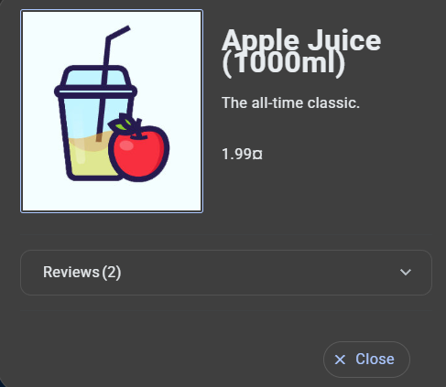
Evidence: product-details view showing the title/quantity overlap.

CY-002 — Review text breaks between characters
Severity: Minor | Category: UI / Typography | Area: Product Reviews
Actual: Review text can wrap at an unnatural character boundary, producing a word split such as “bri” followed by “ght”.
Expected: Words should wrap naturally without arbitrary character-level breaks where the layout permits.
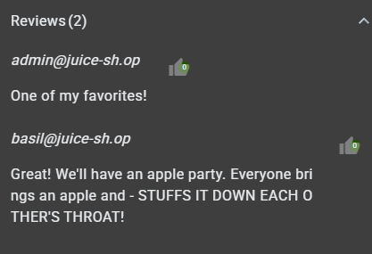
Evidence: review section showing the character-level word break.

CY-003 — Registration validation message overlaps password-help UI
Severity: Minor | Category: UI / Form Validation | Area: Registration
Actual: Leaving the repeat-password field empty displays validation feedback that overlaps the nearby password advice/help control.
Expected: Validation feedback should appear without covering or colliding with surrounding controls.
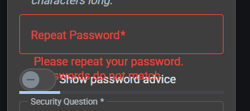
Evidence: registration state showing the overlapping validation message and help control.

CY-004 — Cookie banner cannot be dismissed
Severity: Minor | Category: UX / Cookie Consent | Area: Global UI
Actual: The cookie notification is displayed without an obvious close/dismiss control. The supplied evidence shows the banner with its primary action but no visible X/close control.
Expected: Users should have an obvious way to dismiss the notification where the consent design permits dismissal. The banner should also avoid obstructing important controls at supported viewport sizes.
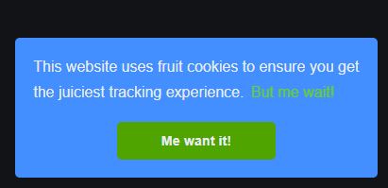
Evidence: cookie banner showing no visible close/dismiss control.
Mobile responsive overlap evidence: ADD YOUR NARROW-VIEWPORT COOKIE SCREENSHOT HERE.

CY-005 — Newly registered account cannot authenticate
Severity: Major | Category: Functional / Authentication | Area: Registration / Login
Actual: A test account created successfully through the normal registration flow could not subsequently authenticate using the credentials established during registration. Login returned “Invalid email or password”.
Expected: A successfully registered user should be able to authenticate using the credentials established during registration, subject to any documented verification requirement.
Evidence screenshot not supplied in this version. Credentials are intentionally omitted from the report.

CY-006 — Sold-out products can be added to basket
Severity: Medium | Category: Functional / Inventory State | Area: Product Listing / Basket
Actual: A product visibly marked “Sold Out” can still be added to the basket through the normal user interface.
Expected: A sold-out product should either be unavailable for addition or clearly communicate that it cannot currently be purchased.
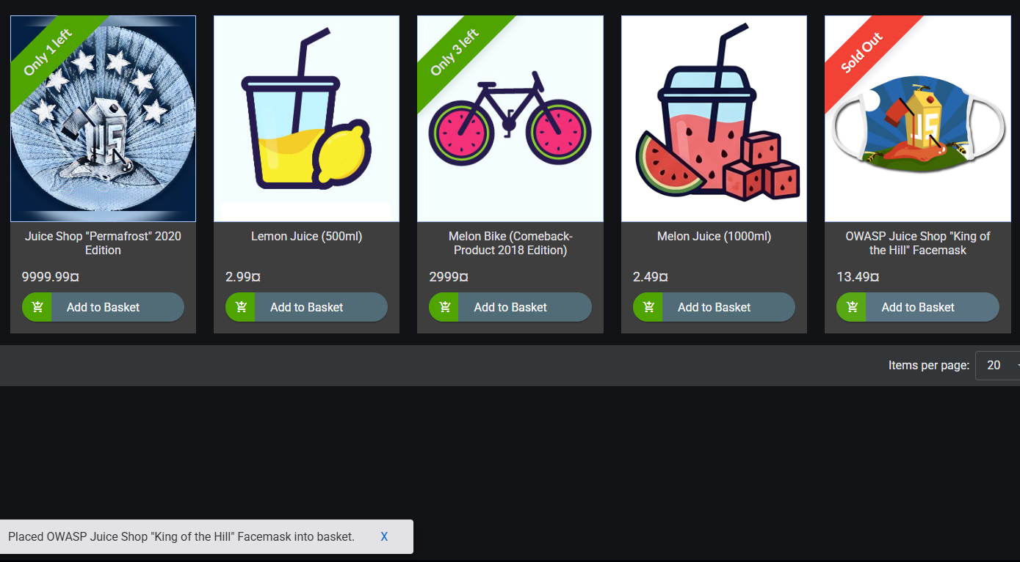
Evidence: product listing showing the Sold Out label and an active Add to Basket control.

CY-007 — Mobile Google sign-in button has insufficient padding
Severity: Minor | Category: Responsive / UI | Area: Authentication / Registration
Actual: At a narrow/mobile-like viewport, the Google sign-in button has very little horizontal padding and the Google icon sits extremely close to the button edge.
Expected: The button should maintain consistent spacing around its icon and content across supported viewport sizes.

Evidence: narrow-viewport Google sign-in control.

6. Observations Requiring Further Validation
Basket performance: A noticeable slowdown was observed when the basket contained many items. No timing, item count, trace, or performance profile was captured, so this remains an observation rather than a confirmed performance defect.
Quantity control at one item: The minus control did not reduce a quantity of one to zero. This may be intentional if the item is expected to be removed through a separate control; validate intended UX before classifying it as a defect.

7. Excluded Security-Training Challenge Notifications
The application displayed notifications indicating that security-training challenges had been solved, including challenges related to two-factor authentication, administrator registration, and the privacy policy. These were not reported as ordinary QA defects because the application intentionally contains such challenges. No security exploitation was performed.

8. Browser / Device Coverage
Environment | Coverage
Opera on Windows — Ultrawide desktop | Exploratory testing performed
Narrow/mobile-like viewport | Responsive exploratory testing performed
Other desktop browsers | Not tested
Physical mobile devices | Not tested

9. Recommendations
- Review the registration/authentication flow to determine why newly created accounts cannot authenticate.
- Prevent sold-out inventory from being added to the basket, or clearly communicate the intended behavior.
- Correct responsive layout collisions involving the cookie banner and registration controls.
- Correct typography/wrapping behavior in product titles and review content.
- Review responsive spacing for authentication controls, including the Google sign-in button.
- Re-test all affected areas after fixes and perform regression checks around registration, product display, and basket flows.
- Measure basket performance using defined item counts and browser performance/network data before raising a formal performance defect.

10. Final Release Recommendation
HOLD / FIX AND RETEST
Based on the limited exploratory scope, the application should not be treated as release-ready without review of the confirmed authentication and inventory-state findings and correction of the identified responsive/UI issues. A full release decision would require broader browser/device coverage, additional functional coverage, and regression testing.

11. Evidence Notes
Screenshots were embedded for the UI, responsive, and inventory-state findings where evidence was supplied. The mobile responsive cookie-overlap screenshot is intentionally left as a placeholder for manual insertion. The authentication finding is documented from the observed test result but has no supplied screenshot in this version. No credentials are included anywhere in the report.

12. Assessment Disclaimer
This document is a demonstration sample created by Cypher to show the structure and quality of its website QA reporting. It is not a client engagement, does not imply endorsement by or engagement with the OWASP Juice Shop project or its maintainers, and does not constitute a security assessment or penetration test.

